**DATABASE PROGRAMMING WITH SQL**

**7.1 Oracle Equijoin and Cartesian Product**

CREATE TABLE employ(

eno VARCHAR(14),

ename VARCHAR(14),

eadhress VARCHAR(15),

epno VARCHAR(15),

depno VARCHAR(14),

depname VARCHAR(14),

jobid VARCHAR(10),

salary VARCHAR(10),

create_date DATE DEFAULT SYSDATE);

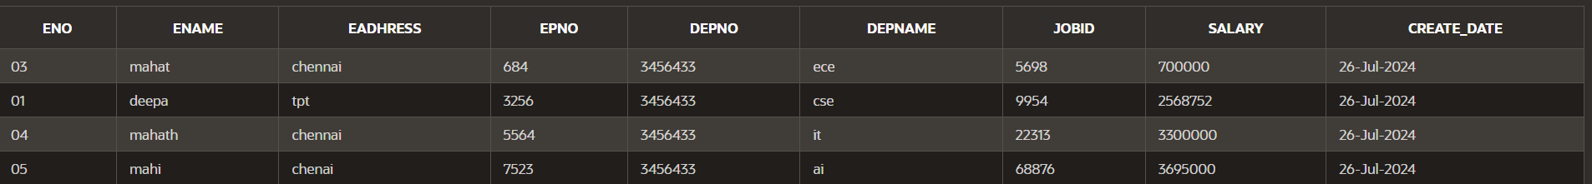

CREATE TABLE jobs (

job_id VARCHAR(10) PRIMARY KEY,

job_title VARCHAR(50) NOT NULL,

min_salary DECIMAL(8, 2),

max_salary DECIMAL(8, 2)

);



**PROPRIETARY JOINS:**

SELECT employ.ename, jobs.job_title

FROM employ,jobs

WHERE employ.jobid=jobs.job_id;



**EQUIJOIN:**

SELECT employ.ename, employ.jobid, jobs.job_title

FROM employ, jobs

WHERE employ.jobid = jobs.job_id;

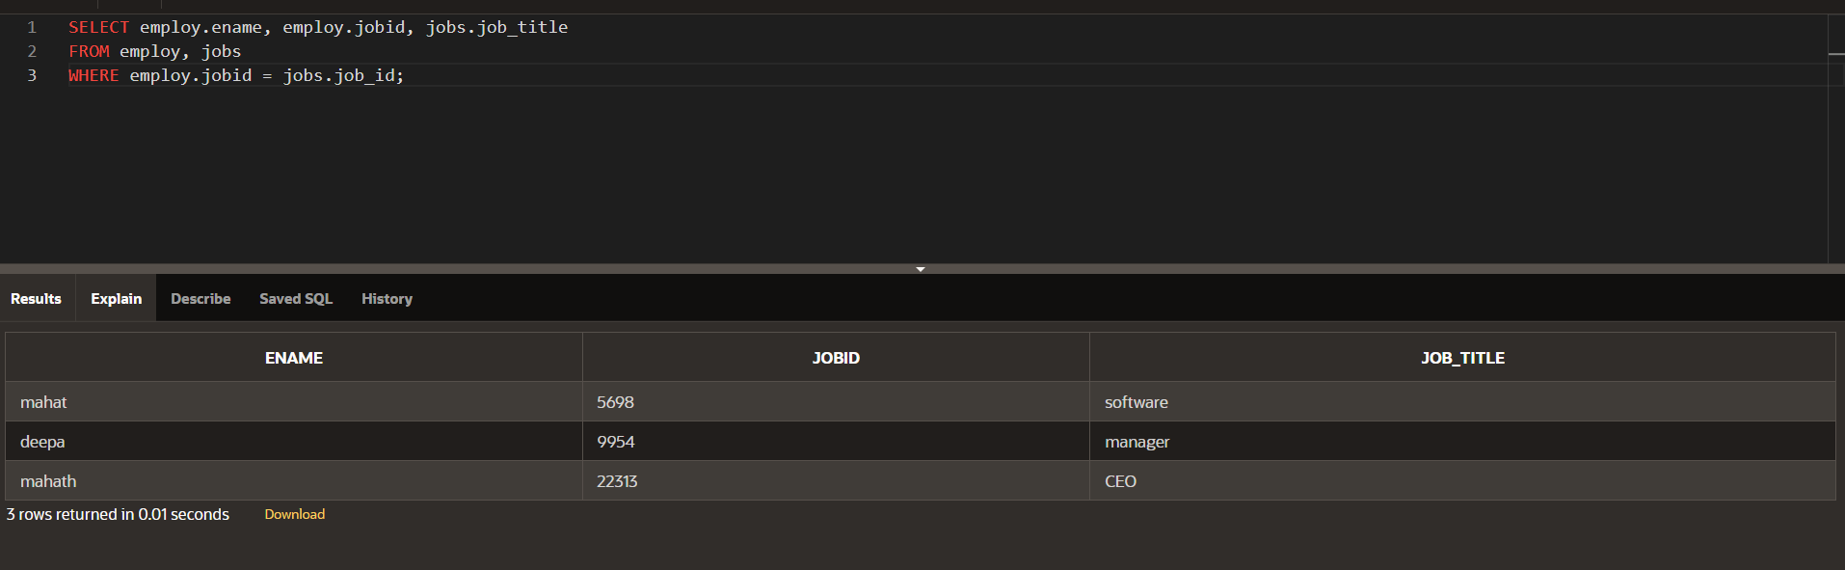

**ALIASES:**

SELECT ename, e.jobid, job_title

FROM employ e, jobs j

WHERE e.jobid = j.job_id

AND depno=3456433;

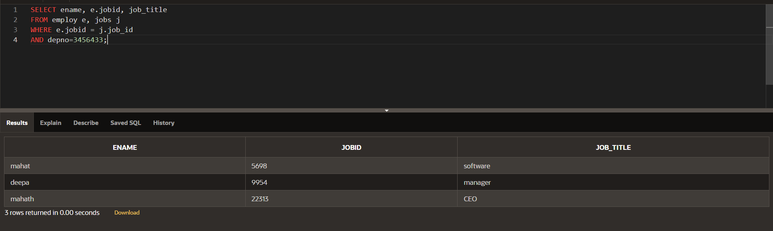

**CARTESIAN PRODUCT JOIN:**

SELECT employ.ename,jobs.job_title

FROM employ,jobs;

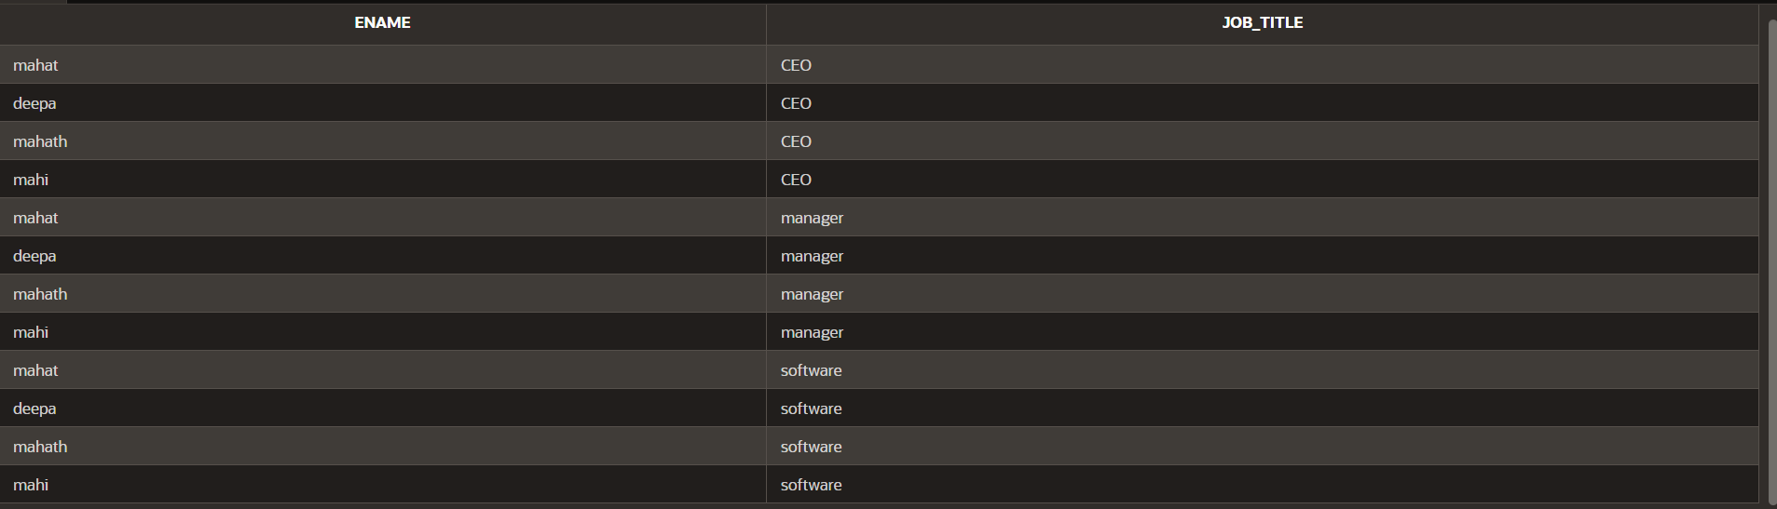

**JOIN:**

SELECT last_name, location

FROM Employes e, departments d, jobs j

WHERE e.job_id = j.job_id

AND e.department_id =d.department_id;

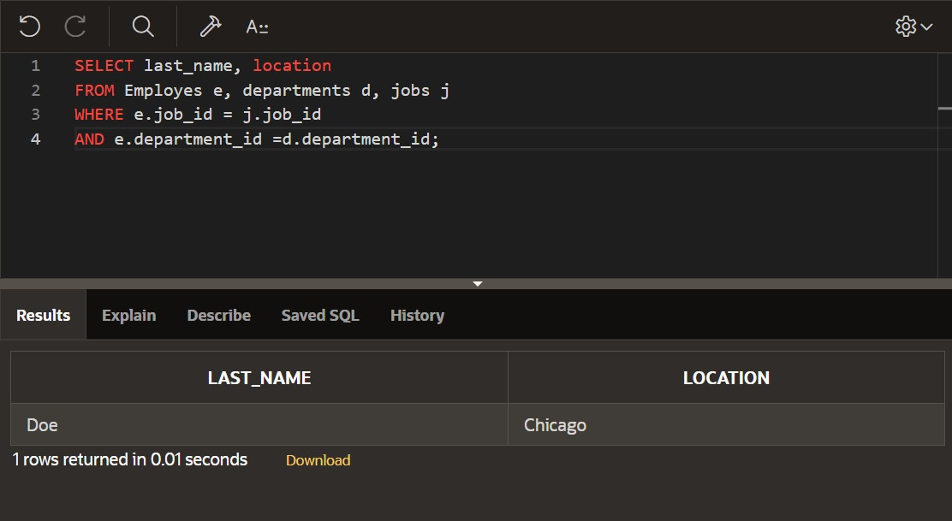

**DP_7.2:**

**Nonequijoin:**

SELECT ename,salary,grade,lowsal,

highsal

FROM employ,job_grade

WHERE (salary BETWEEN lowsal AND highsal);

